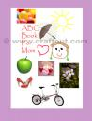 ABC book for Mom on Mother’s day It’s easy and fun to create this book that won’t have duplicate all over the world! Using pictures from magazines, your own pictures, stickers, crayons or markers, and your imagination, of course, you’ll create something your Mom will cherish for years!

 Advent Collage – This is a fun way to count down the days until Christmas. Make an advent collage with these printable templates and magazine pictures.

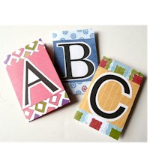 Alphabet Book These Alphabet Books are a nice afternoon craft that doubles as a learning tool.

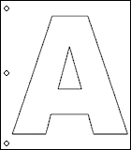 Alphabet Collage Book - Make your own alphabet collage book using printable alphabet letters and these directions.
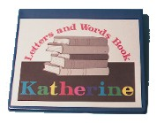 Alphabet Letters and Word Book Can your child sing the alphabet song, but doesn't know that 'elemenopee' is actually five different letters from the alphabet?

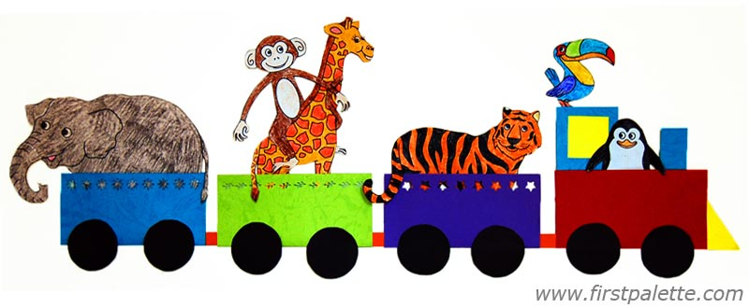 ANIMAL TRAIN Create a train for your favorite paper animals. This is a great animal craft to make before or after a visit to the zoo. It can also be used as a fun and exciting way of introducing animal and habitat facts.

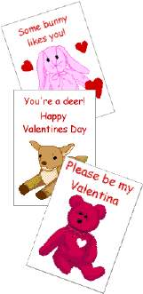 Beanie Valentines These homemade Beanie Baby Valentine's Day cards make a heartwarming treat. Children can add their own personal touch with bright markers and fun stickers.

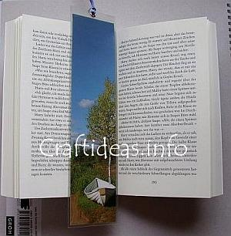 Bookmarker Read in style with your own personally crafted bookmark. Bookmarks are quick and easy to make and require a minimal amount of material.

 CD Box Picture Frames Want an inexpensive but unique picture frame that you could give out as gifts to your loved ones? This is just the craft for you. Bring out the old magazines and clip out pictures to add on to your frame for a blasting style.

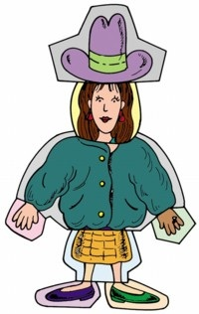 Character Collage Puppets Create a family of silly paper craft characters using some old magazines, scissors, glue, and your imagination.

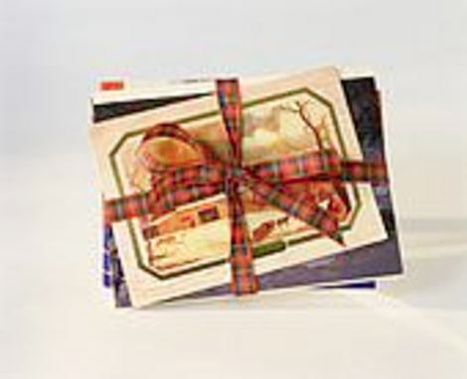 Christmas Cards Kids Can Make Out of Recycle Craft Materials This easy Christmas card craft project is the perfect project for kids during the holidays. You can make these simple and beautiful Christmas cards out of old magazines and other recycled craft materials you can find around the house!

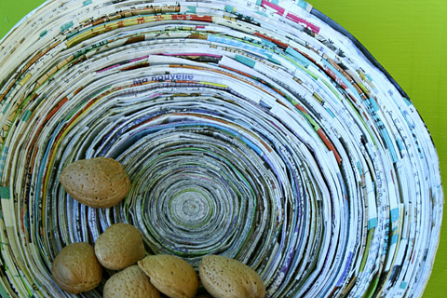 Coiled paper basket Magazines can be recycled into coiled paper baskets that are reminiscent of wood's concentric rings or turned wood. Using a magazine and 1 pint of rice glue, you can make a fruit bowl, a pencil holder or a basket for trinkets.

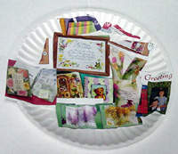 Collector's Plates This craft is easy to do and fun to make. Keep those little ones busy making these easy decorations for their tree.

COLORFUL COASTERS - A great gift idea that makes use of recycled materials found around the home.

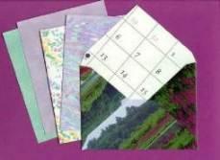 Create an Envelope There was a time when everything was made by hand, but the American Industrial Revolution of the late 18th Century resulted in the introduction of machinery and a major change in the way products are manufactured in this country. Today we've become so used to mass-produced goods that we give little thought to how they're made.

Cut and Paste Collage This cut and paste collage is a fun way for kids to make homemade cards for any occasion. Whether for Mother's Day, Father's day, or even a brother or sister's birthday, this is a great way to get some use out of old magazines and newspapers.

DAD'S SURVIVAL KIT This is an excellent way for young children to express what they feel dad needs from them and by decorating the box on the outside, it becomes a special piece of artwork from the heart.

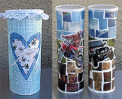 Decoupage Coin Banks Encourage your kids to save their hard earned money by making these fun coin banks. Using recycled containers and old magazines, you can transform garbage into functional items, all while teaching your kids the importance of managing their money.

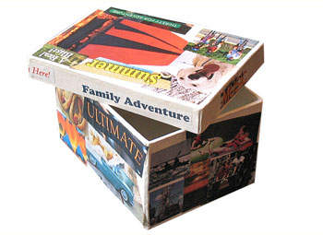 Decoupage Collage Box With a few craft sticks, some paint and a lot of imagination, your child can have a personalized door hanger to call their own. This project is simple and it’s fun to make.

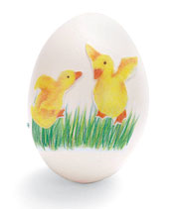 Decoupage Designs You don't have to be an artist to create these keepsake eggs. Just cut illustrations or photos from magazines, scrapbooking supplies, or other printed sources, or download them from the Web.

Dinner Hats It's customary in our part of the world to remove your hat when you eat. We'll break with tradition for this activity and encourage kids to make hats for everyone to wear at the dinner table.

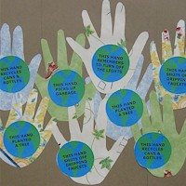 Earth Day Helping Hands This FreeKidsCrafts.com original project is the perfect classroom project for Earth Day. We used old wallpaper book samplers to make the hands. You can also use paper bags, magazine pages, comics or just about any other type of recycled paper.

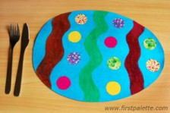 EASTER EGG PLACEMAT Set the table for Easter with your own Easter egg placemat creations.

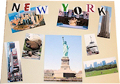 Favorite Places Collage Craft People of all ages and abilities can enjoy creating collages. If you are looking for some inspiration, why not choose a famous or favorite place as theme.

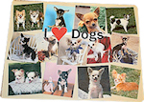 Favorite Things Collage Craft People of all ages and abilities can enjoy creating collages. If you are looking for some inspiration, why not choose one of your favorite things as a theme.

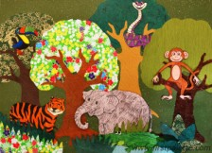 FOREST COLLAGE Use interesting textures and colors of paper and fabric to create a forest collage. Create a pine forest, an autumn forest, a woodland forest, or a rainforest. You can even add animals to make your forest come alive.

Fun Jars - Make this Craft using discarded baby food jars and some cut-out magazine images.

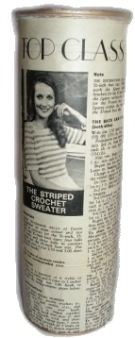 Funky Vintage Tin - This project uses a recycled crisp tin to create a funky organizer for pencils, small knitting needles, crochet hooks or just about anything else you fancy.

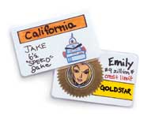 Funny ID Cards - If your kid likes to play make-believe, creating a pretend ID or credit card for her alter ego, a pet, or her favorite cartoon character is sure to spark her imagination further.

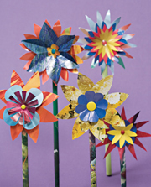 Glossy Paper Flowers - Far from the garden variety, these blossoms stem from magazine pages. They're easy to make and leave lots of room for inspired creativity.

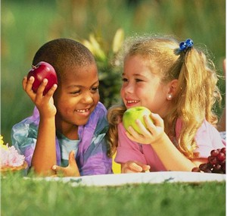 Healthy Food Chart - This art project will teach young children the importance of good health and healthy choices.

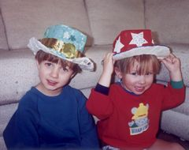 Holiday Hats – These are the most fun and easy to make kiddie crafts whatever the occasion calls for. Did we mention fun?
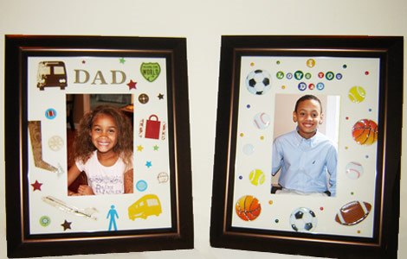 Homemade Frame Give your dad a custom-framed picture of you on Father's Day!

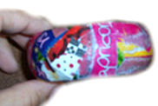 Horoscope Bangle – Little girls love these easy to make home-made crafts not just because it is made for girls but also because they can personalize it to whatever color they want.

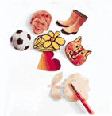 Instant Stickers Kids can never have too many stickers, and here's a fun way to keep your family well supplied.

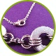 Jewelry Crafts for Tweens Making jewelry is a great way to let a tween express her creative nature. Here are some of the more popular handcrafted jewelry ideas for tweens.

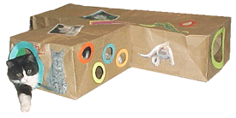 Kitty Condo You and you cat will have hours of fun in this home built just for him!

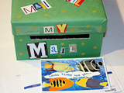 Make a Mail Box - When you read through the directions for this activity, you may think it does not sound like much fun, but, believe me, the kids will love it. You can also use this as a Saint Valentine's Day activity!

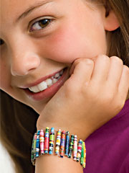 Magazine Bead Bracelet Recycle old catalogs and magazines into stretchy, swanky bracelets that cost next to nothing to make.

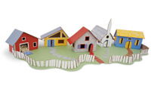 Magazine Box Town Being stuck in the house all day doesn't mean you have to spend your time staring at the same old walls. Instead, you can build new ones. With a few magazine and file storage, you can construct an entire play village in an afternoon.

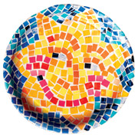 Magazine Mosaic - What's a mosaic? It's a picture crafted with lots of small tiles -- or in this case, paper squares.

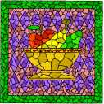 Magazine Mosaics - Using magazines or photos, you can achieve an effect similar to mosaics formed of glass, clay or stone.

 Magazine Purse - Young little girls will love making this project with Mommy helping them! See the young little ladies make a fashion statement using their imagination and some recycled magazines.

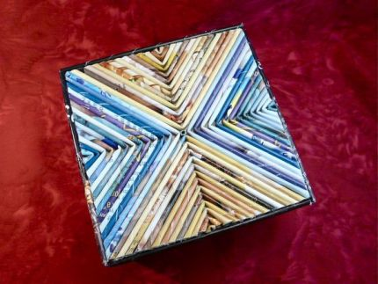 Magazine Reed Box - Tightly rolled magazine pages make gorgeous reeds, which you can use to cover all kinds of things.
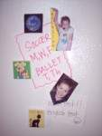 Magnetic Locker Décor Turn some of your favorite photos and mementos into locker décor. Collect pictures from magazines, photos of friends, a mini collage of movie tickets, or an old paperback book cover from your favorite book, the list goes on and on!

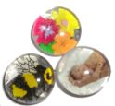 Marble Magnets – With some old magazines and a little bit of creative flair, you and your kids can easily make your own, personalized marble magnets craft and place it on the fridge.
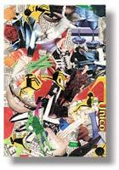 Media Collage – There’s no better way to make your child’s artistic side come out than to let him/her create this easy to do media collage using the old magazines that are collecting dust in your garage.

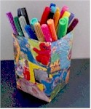 Milk Carton Pen Pot - Teach your kids the value of tidiness by helping them make this pen pot made out of milk carton and some old magazine cut-out.

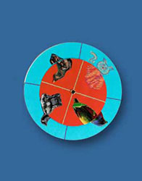 Mix & Match Animal Games - Kids mix and match different animals to make unusual kreatures. Encourage creative thinking by asking questions: What if a hippo had a bird's body? What if a camel had paws like a tiger?

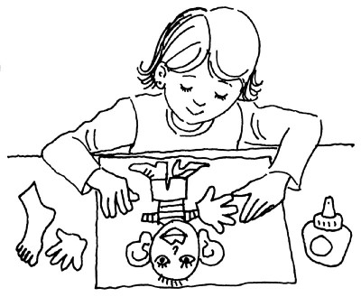 Mixed-Up Creature Find out what it's like to be a mad scientist with this goofy cut-and-paste mixed-up creature.

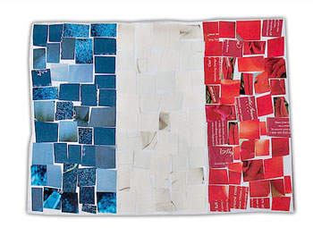 Mosaic French Flag Kids love to create, and this mosaic French flag craft is a great way to display their individual creativity. No one flag craft will be the same as the other. Celebrate Bastille Day by doing a mosaic craft French flag of your own.

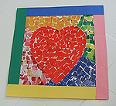 Mosaic Valentine Heart It's completely up to the creator in this craft. You decide how easy or challenging it will be, and how long it will take. All you need are some old magazines, construction paper, and glue and you can make these fun Valentine heart.

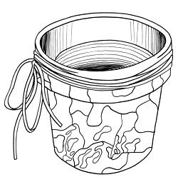 Mother’s Day Flower Pot - Instruct children to choose several different pictures from magazines, cut out pictures and organize these on a pot. They can also plant a pretty flower in it as a surprise for Mom on Mother's Day.

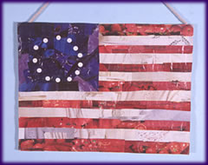 Old Glory Collage – Show your children the value of patriotism by helping them make this Old Glory flag from the Civil War Era using simple materials such as paste or glue, scissors, some old magazines, and bit of creativity.

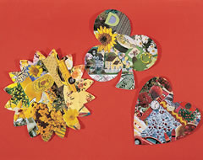 One-Color Collage – Allow your children’s creative mind to wander off in making this fun craft project and see the results when they are done. You will surely be surprised with what they can come up with.

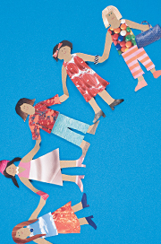 Paper Bag & Magazine Dolls - This couture-inspired project lets kids give a paper bag and some old magazines a truly unique “model makeover”.

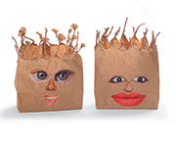 Paper Bag Gargoyles Create your own gang of simple but undeniably spooky lunch bag faces to set along your window ledge and welcome -- or ward off! -- your trick-or-treaters.

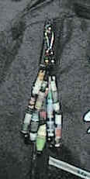 Paper Bead Key Chains A cute retro look for your backpack. We just used old magazines, but if you wanted something a bit more color coordinated you can use gift wrap or other colored paper.

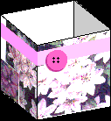 Paper Jewelry Box -This Earth Day why not recycle an old box to create your own treasure chest? Kids can store trinkets and more with this Paper Jewelry Box craft.

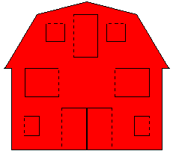 Peek-A-Boo Barn Picture - Make a picture of a barn using old magazines or catalogs and let your kids add some farm animals inside for a fun filled activity.

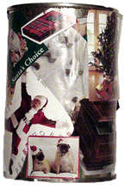 Pen holder Collage - Give someone a great personalized gift with this Pen holder collage. This scrapbook craft is fun and creative way to recycle old magazines and newspapers too.

Pet Matching Game Decide what kind of matching game you want to make. You can make it to match adult and baby animals, animals of the same species, animals of the same color, etc.

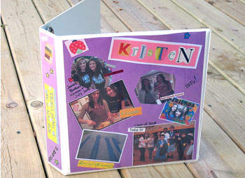 Photo Binder As your kids get older they will start carrying a binder to hold all their homework and assignments. Make their binder a fun keepsake from summer with their friends, time at camp or pictures from last school year.

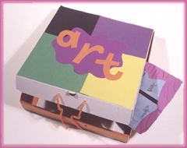 Pizza-Box Art Portfolio – This will surely come in handy for your kids at school. Not to mention that it is both creative and unique!

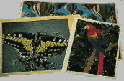 Picture File What does a koala look like? How do you draw a jeep? Which way do the stripes run on a zebra? You'll know the answers to these and many other questions, and you can save a lot of paper from going to the landfill by making a picture file.

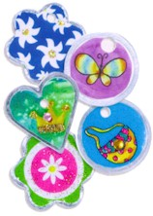 Picture Tag Charm Necklace – Do-it-yourself trinkets are the fad these days with our young ones. Why not help them make some for their own collection? Use some old magazines to brighten up your creation.

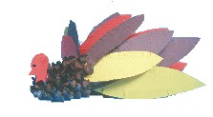 Pine Cone Turkey Let the kids make these turkeys to decorate for Thanksgiving, or use them to hold place cards on your holiday table.

Reader's Digest Angel - SusieQ shares instructions for making an angel decoration using a Reader's Digest or similar magazine or catalog.

Reader's Digest Tree - Find out how you can transform a Reader's Digest or similar magazine or catalog into a Christmas tree tabletop decoration

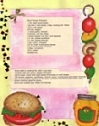 Recipe Scrapbooking – Food can be so colorful when mixed and matched- and so does this art craft which you can do with your kids to teach them the importance of a hearty meal!
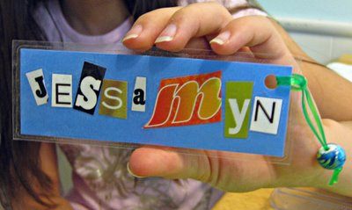 Recycled Bag Tags & Bookmarks - Nothing can compare to a personalized bag tag or bookmark especially when Mom or Dad helped in making them. This fun craft can easily be made in minutes using just a pair of scissors, glue and some old magazines which can be seen lying around the house.

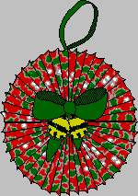 Recycle Cards and Wrapping Paper - Recycle cards and wrapping paper to make great Christmas ornaments but also can be decorated for ANY occasion.

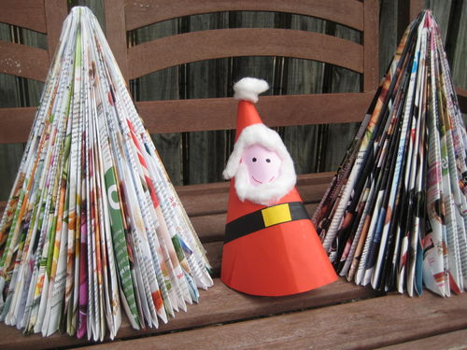 Recycled Christmas Tree – Collect all the old magazines you have compiled for the year and make use of them by recycling it into, say, a Christmas tree for the Yuletide season. Kids will have a swell time in making this fun craft.

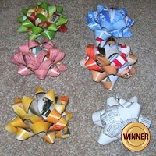 Recycled Magazine Bows - These bows are so pretty everyone will think you bought them at the store.

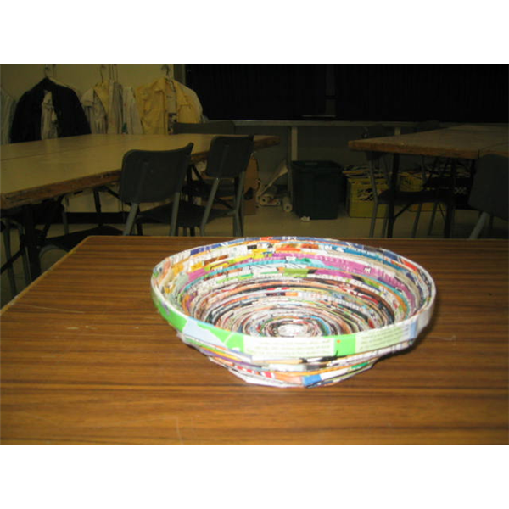 Recycled Magazine Bowl - Recycled art is easy to create. Students can create a bowl from magazine pages and discover that using recycled materials is fun, beautiful and useful. This art project is for students in grade 4 - 8. Teachers can teach about paper recycling in a new way with this easy recycled art project.

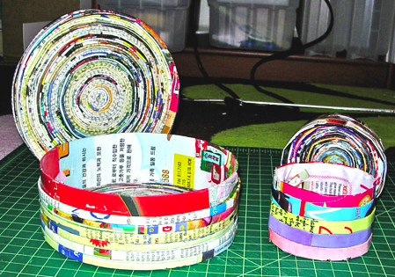 Recycled Magazine Boxes Perfect timing! We've got two large stacks of magazines just sitting in our living room. Instead of dumping them all in the recycling bin, we can now turn them into a great DIY project.

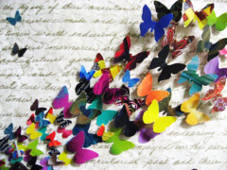 Recycled Magazine Butterfly Collage – Help the environment by making use of all your discarded magazines and tuning it into something fancy and decorative such as this butterfly collage. Kids will love the effect it will have in their bedroom.

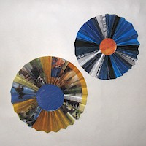 Recycled Magazine Flowers - Make large, grand flowers from folded old magazine pages.

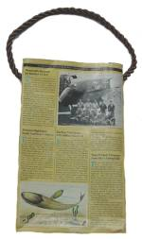 Recycled Magazine Handbag - This particular pattern uses National Geographic magazine but any recycled magazine will work to make your own handbag.
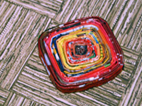 Recycled Magazine Page Coaster We all have a million magazines in our homes that we don’t want to just toss into the recycle bin. All of those lovely colors and fonts going to waste! But these very useful and beautiful coasters can use up all of those pages, as well as show off the colors from the ads and photography long after we’ve finished reading about the spring fashion of 2008.
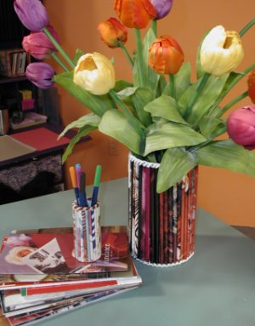 Recycled Magazine Rollups – Find good use to your old magazines and make something extraordinary out of it together with your children for some bonding moment.
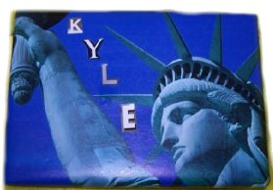 Recycled Magazine Wrapping Paper - Use colorful magazine pages to wrap small gifts - works great for VHS tapes, DVDs and Video Games.
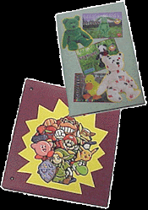 Recycled School Supplies – Let’s face it, not all school supplies that your kids bring to school end up getting used at all. Save some cash for the next school year by helping your kids make some recycled items using some of the old magazines lying around in your basement.
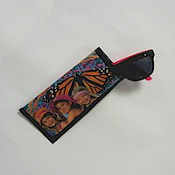 Recycled Sunglasses Holder - Wow! Here's another great original recycling craft which is just in time for summer fun in the sun. It's so inexpensive; you can make one to coordinate with every outfit.
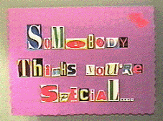 Secret Valentine - Have you ever wanted to disguise your handwriting so that you could send an anonymous or secret valentine to someone? You won't have to write a word if you make this ransom-style card.

Shiny Paper Beads - Make your own jewelry and other great stuff with these shiny paper beads. Kids will have fun cutting out colorful pictures from old magazines to create beads that can be used in almost any craft.

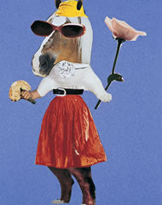 Spare Parts Picture - Who says that only cameras can make pictures? With some good old magazines, you can mix and match all the colors to create a fancy art craft project such as this one.
 Springtime or Anytime Place Mat - Design your own springtime or anytime place mat. They are great for any occasion and will brighten your home.
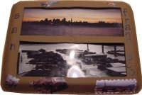 Styrofoam Tray Frame -
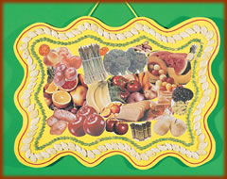 Sukkot Harvest Scene - The word “Sukkot” is the plural of the Hebrew word ‘sukkah’, meaning booth or hut. It is a type of thatched hut in which the ancient Israelites dwelt during their 40 years of wandering in the desert after the Exodus from Egypt.
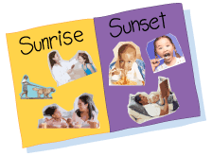 Sunrise / Sunset Collage Learn how you can create your very own collage about different times of each day, sunrise and sunset!

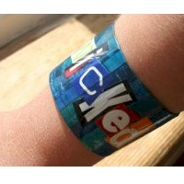 Toilet Paper Roll Bracelet This is a very simple, creative recycling project children will love. It's very quick to make and fun for kids of all ages. The best part is it's made with scraps most of us have around the house.

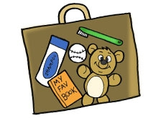 Travel Suitcase Our friends from Panwapa Island do a lot of traveling around the world! Pretend you are going on a trip with Azibo and his friends, and make your very own suitcase out of construction paper to fill with all the things you plan to take!

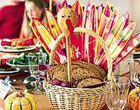 Turkey Breadbasket If the decision had been Ben Franklin's to make, the wild turkey (a creature he considered more respectable than the bald eagle) would have been named the national bird. Here's a gobbler that's sure to be a winner on Thanksgiving Day.

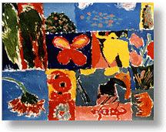 Viewfinder Painting - With this craft project, students will learn to look at the different ways of laying out a painting and will begin to recognize important elements of design.

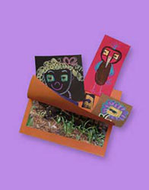 What’s the Mystery Picture? - Who can keep a surprise? Ask them to make your mystery game. Then peek through the tiny hole. What do you see?

Who am I? This game is a great ice breaker games for the first time a new group of kids gather together. This game gives children a reason to talk to each other without wondering how to start the conversation.

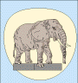 Wildlife Scenes - Create your own wildlife scenes using pictures of animals found in old magazines. You can also use this same method to create nature and action scenes.

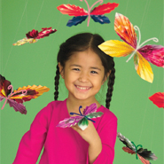 Winged Wonders - What makes these fluttery butterflies so vibrant? Magazine photos!

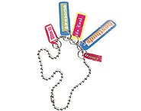 Word for Word Necklace - What's your child's favorite band? What does she think is cool? Does she have a favorite expression? Now she can tell the world with this easy-to-update charm necklace.

